
Design and Construction of Ackerman Steered Robot

Deliverable 3: Resubmission
EML4551

Group 14
October 16, 2008

QUINN, KYLE
SOSA, JULIO
STEEL, ROBERT
WOODS, TREVOR


Table of Contents

Abstract 2

Introduction 2

Product Specifications 2

Conclusion 6

Works Cited 7

Appendix 8
Abstract

Our group in the senior design course at the FAMU-FSU College of Engineering is tasked with designing and constructing an Ackerman steered robotic vehicle for the Center for Intelligent Systems, Control, and Robotics. With no product of this description available for over the counter purchase, we are challenged to take the customers needs and create a measurable set of specifications from which to base our design process. Should all these specifications be met, the result will be a versatile platform for robotics and control research.

Introduction

The Center for Intelligent Systems, Control, and Robotics (CISCOR) at the FAMU-FSU College of Engineering is the customer and primary financial support for our groups, Group 14, senior design project. We are charged with the design and construction of an Ackermann steered autonomous robotic vehicle to test intelligent controls systems on and off road. The task of constructing an Ackerman steered robot is unique in the respect that currently there are no off the shelf products available for the public, or research facilities. Because of this our customer, CISCOR, has granted us a particular amount of freedom for the design of the final product.
We found that the customer needs were basic in comparison to the many directions that this product can go. In addition, the customer has already provided us with many of the components that will be used on the robot, including the electric motors, laser sensors, and control systems. Leaving our primary design focus on the vehicles steering and suspension.
Before we can begin to design, it is important to take the customer needs and wants, and convert them into measurable specifications from which to base our design process. Each of the following specifications were chosen to meet the customers wants to the fullest potential, while at the same time keeping the design within monetary, time, and functional constraints.

Product Specifications

- 4- Wheel Ackerman Steering
  - The primary need of this product, it is the only non-negotiable specification that the product vehicle must be capable of. All other specifications are subject to change based on the accomplishment of this. The key feature in Ackerman steering is a spindle at the end of each vehicle axle that pivots around a kingpin. A four-bar linkage is formed with the axle as base, and additional links connecting the spindles to form a trapezoid (Stone 304). The advantage of this system is that when turning, the inner wheel turns at a greater angle, providing sharper steering.

Figure (1) Two Wheel Ackerman Steering Example
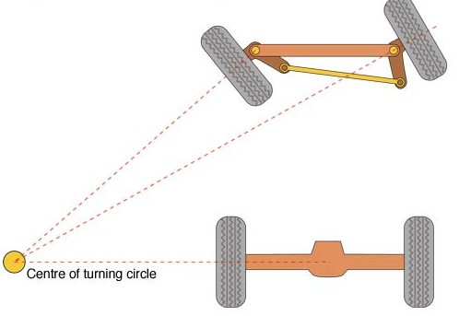

- 4-Wheel Drive
  - This robot will be electronically controlled, per request of customer. Provided to us were 4 Maxon electric motors to propel each wheel individually. The provided computer control system will be integrated with the motors to have full control of each wheels traveling speed.

Figure (2) Sample Maxon Electric Motor
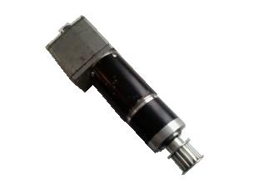

- Independent Suspension
  - The next need of the customer was off road capability for the vehicle. Combined with the Ackerman steering assembly this can lead to issues in terms of clearance between suspension components and steering components. A 4-wheel independent suspension system will resolve this problem better than any other set up because there will be a minimal amount of linkages traveling through the vehicle that could get in the way of steering. Considerations, however, will have to be made to verify that the independent movement of each wheel will not put un-necessary stress on steering components leading to linkage failure.
- Dry Weight (Unloaded) - 150 lb or less
  - As stated before, CISCOR has already provided us with many components that will be used for the construction of the vehicle. Inventory of set components was taken, inclusive of their individual weights. Combined with a reasonable estimate of the amount of metal stock, that will be used to fabricate the frame and suspension, we decided on our target dry weight.
- Wheelbase 36”x36”
  - The customer’s desired size for the product was that which would contain all provided equipment in the smallest package possible. Aware of equipment size, the customer themselves stated the product will be anywhere between the size of a radio controlled truck, and a small go-cart. Taking into account the dimensions of provided equipment, it is felt that the wheelbase chosen should be sufficient, if not more than enough to accommodate set components.
- Ground Clearance - 4”
  - As stated before, this vehicle must be all terrain. Depending on the desired size of the vehicle, clearance can work either for, or against its handling. Based on the products size and terrain, our group came to a ground clearance of approximately 4”.
- Body Height - 16”
  - Very similar to wheelbase, our height specification is a product of the required equipment the vehicle must carry. The tallest component provided was the SICK laser which will guide the robot. Combined with ground clearance, the specified height will be at the tallest point of the product.

Figure (3) SICK Laser Sensor
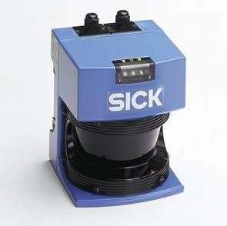

- Capable of traveling through 5”-6” of standing water
  - It is the common understanding of the group, as well as customer that all terrain travel may encompass a water hazard. Although not intended for water based use, it must be capable of withstanding basic water hazards. With a ground clearance of 4”, many of the possible water events are taken care off, but with the possibility of greater submersion, or water splash, we decided that the robot requires the capability of traveling through 5’-6” of standing water. In addition the body must be capable of withstanding an average rainfall. For water hazard greater than what is stated it is the recommendation that the final product not be used.
- Top Speed – 10mph or greater
  - The customer gave no necessary speed. However the group feels for efficient use, the final product will have to travel at top speeds of 10 mph or greater. Top speed is based on straight line, flat terrain conditions, and will not be recommended speed for all hazardous terrain use.
- Towing Capacity – 100lb
  - Electric motors are known for having torque advantage. From a design perspective, the group would like to see this vehicle be able to tow small – medium items from the rear of the frame. An example of an item is a small 4-wheeled cart with some cargo.
- Climb 30º incline
  - In many instances, off road driving brings a vehicle to a hill obstacle. A 30º incline in a reasonable hill for the product to maneuver without failure of any kind. Tire grip and vehicle slip is a consideration, however the frictions of hilled surfaces are not all the same, and therefore cannot be fully prepared for.
- Function for 60 minutes between charges
  - As a battery operated machine, time between charges is a major consideration. The disadvantage of a robot whose battery life is very short far outweighs any other advantage it may have. However the batteries have already been provided to use, and therefore there is not much to do in the way of power systems. As a group it is our responsibility to assemble the product properly so as to take advantage of all power cells provided. This specification may be subject to change when the testing phase has been reached.
- Easy Assembly
  - By request of the customer, this product needs to be easily disassembled for maintenance as well as any future upgrades. This includes, but is not limited to, quick outer body removal, easy access to main circuit board, and primary control systems, and easy replacement of SICK laser.
- Ability to rotate on its own radius
  - Should all other specification be met with the design, is it the request of CISCOR that the steering also contain a locking mechanism. When the wheels are all locked in parallel position, the left and right wheels will have the capability of traveling opposite directions so as to rotate the vehicle on its own radius. This method is known as skid steering.

Conclusion

All specifications are subject to change during the design process, and are meant to be guidelines, not absolutes. Additional specifications may arise, but will come secondary pending the accomplishment of those listed above. Appendix (1) contains an inventory of items provided to us by CISCOR, that all must be implemented in the final product. When finished, the vehicle will provide a functionally sound, and open-ended platform for vehicle robotics and control research in all terrain applications.

Works Cited

Stone, Richard, and Ball, Jeffrey K. Automotive Engineering Fundamentals. Warrendale: Society of Automotive Engineers, 2004.

Figures (1)
< http://upload.wikimedia.org/wikipedia/commons/7/70/Ackermann_New.jpg>

Figure (2)
< http://www.elektromehanika.com/servo/maxon%20motor.jpg>

Figure (3)
< http://www.pages.drexel.edu/~kws23/tutorials/sick/sickLMS200.jpg>

Appendix

- Inventory of CISCOR supplied components

Part Number | Weight (g) | Qty | Description
317767 | 3570 | 2 | 150W Maxon DC Motors w/ 66-1 Gear Ratio
 | 1770 | 4 | 250 W Maxon EC Motors (Brushless/AC) w/21-1 Gear Ratio
201583 | 440 | 2 | Maxon Motor Control (DC) ADS 50/10A
228597 | 440 | 4 | Maxon Motor Control (EC) DES 70/10A
PCM3370 | 162 | 1 | Advantech PC104 Computing System
 | 100 | 2 | Data Acquisition Sensora 526
 | 200 | 1 | Tri-m power supply
 | 1200 | 2 | Tenergy Li-Polymer Rechargeable Battery Pack 37V 4,000mA 15C
 | 686 | 1 | Tenergy Li-Polymer Rechargeable Battery Pack 22V 4,000mA 15C
LMS200 | 4500 | 1 | SICK Laser

